Figure 1. Localities where the focal southern capuchinos were recorded. Each locality is indicated with a blue point, and the abbreviations of the locality names (EI, E, ER, MC, S) are given in parentheses. Illustrations of the southern capuchinos indicate the species that breed in each locality according to ebird. The names of the species are detailed in the legend.

Figure 2. Principal component space (PC1-PC2) of the vocalizations of the focal southern capuchinos. The principal component spaces were constructed for: A) Simple songs, and B) Complex songs. The principal component spaces of each song type were based on acoustic parameters estimated per song and per element. The four southern capuchino species are represented with different colors (references in the legend).
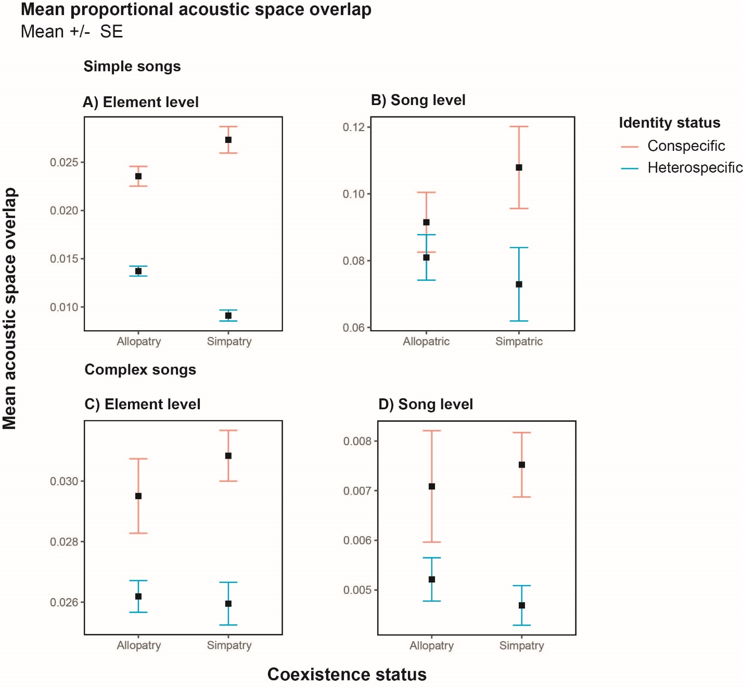
Figure 3. Acoustic space overlaps of conspecific and heterospecific individuals in allopatry and sympatry. Mean proportional acoustic overlap (± SE) of the pairwise individuals according to their identity (conspecific or heterospecific) and coexistence status (sympatry or allopatry). Light blue bars represent conspecific individuals, while salmon bars represent heterospecific individuals (see legend). The proportional acoustic overlap was measured for simple and complex songs on acoustic parameters estimated per element (A and C) and per song (B and D).

Figure 4. Acoustic variation of the simple songs of the focal southern capuchino species. Mean scores (± SE) for each species on the retained PCs representing the acoustic variation estimated per element (A) and per song (B). The four southern capuchino species are represented with different colors (references in the legend).

Figure 5. Acoustic variation of the simple songs of the focal southern capuchino populations. Mean scores (± SE) for each species on the retained PCs representing the acoustic variation of the populations estimated per element (A) and per song (B). The different bar colors represent the species to which each population belongs (see legend). The localities where the species were recorded are identified with their abbreviations (EI, E, ER, MC, S). S. iberaensis and S. palustris were recorded only in Esteros del Iberá, and these populations are indicated by a combination of the species epithet and the locality abbreviation (ibe-EI, pal-EI).
Tables
Table 1. Variability of simple song acoustic parameters estimated per element among southern capuchino species. A) Results of the linear mixed models that assess the effect of species identity on the principal components (PCs) summarizing acoustic variation. For each PC, the table reports the estimated effect size (Value), standard error (SE), test statistic (t), and significance level (p). B) Tukey post-hoc contrasts show pairwise statistical differences (Est.) between species for each principal component (PC), the standard error (SE), test statistic (t), and significance (p) of those differences. The ANOVA test statistic (F) and the significance of the overall model (p) are reported at the bottom. Significant p-values are indicated in bold and italic.
A)
Simple song
Element level
Species | PC1 |  |  |  | PC2 |  |  |  | PC3
Species | Value | SE | t | p | Value | SE | t | p | Value | SE | t | p
Intercept | 0.63 | 0.13 | 4.77 | <0.0001 | 0.92 | 0.34 | 2.69 | 0.01 | -0.08 | 0.39 | -0.21 | 0.84
S. iberaensis | -0.79 | 0.50 | -1.58 | 0.12 | 0.94 | 0.59 | 1.60 | 0.11 | -1.11 | 0.44 | -2.54 | 0.01
S. palustris | 1.84 | 0.29 | 6.33 | <0.0001 | -3.39 | 0.40 | -8.44 | <0.0001 | -0.59 | 0.31 | -1.87 | 0.07
S. ruficollis | -1.69 | 0.20 | -8.42 | <0.0001 | -1.51 | 0.33 | -4.61 | <0.0001 | -0.07 | 0.27 | -0.27 | 0.79
ANOVA | F = 52.65, p < 0.0001 |  |  |  | F= 33.21, p < 0.0001 |  |  |  | F = 2.73, p = 0.05

B)
Simple song
Element level
Species contrast | PC1 |  |  |  | PC2 |  |  |  | PC3
Species contrast | Est. | SE | t | p | Est. | SE | t | p | Est. | SE | t | p
S. hypoxantha vs S. iberaensis | 0.79 | 0.50 | 1.58 | 0.39 | -0.94 | 0.59 | -1.60 | 0.39 | 1.11 | 0.44 | 2.54 | 0.06
S. hypoxantha vs S. palustris | -1.84 | 0.29 | -6.33 | <0.0001 | 3.39 | 0.40 | 8.44 | <0.0001 | 0.59 | 0.31 | 1.87 | 0.25
S. hypoxantha vs S. ruficollis | 1.69 | 0.20 | 8.42 | <0.0001 | 1.51 | 0.33 | 4.61 | 0.0001 | 0.07 | 0.27 | 0.27 | 0.99
S. iberaensis vs S. palustris | -2.64 | 0.55 | -4.81 | <0.0001 | 4.32 | 0.64 | 6.79 | <0.0001 | -0.53 | 0.47 | -1.11 | 0.68
S. iberaensis vs S. ruficollis | 0.90 | 0.51 | 1.78 | 0.29 | 2.45 | 0.66 | 3.74 | 0.002 | -1.04 | 0.51 | -2.05 | 0.18
S. palustris vs S. ruficollis | 3.53 | 0.30 | 11.79 | <0.0001 | -1.87 | 0.50 | -3.77 | 0.002 | -0.51 | 0.41 | -1.26 | 0.59

Table 2. Variability of complex song acoustic parameters estimated per element among southern capuchino species. A) Results of the linear mixed models that assess the effect of species identity on the principal components (PCs) summarizing acoustic variation. For each PC, the table reports the estimated effect size (Value), standard error (SE), test statistic (t), and significance level (p). B) Tukey post-hoc contrasts show pairwise statistical differences (Est.) between species for each principal component (PC), the standard error (SE), test statistic (t), and significance (p) of those differences. The ANOVA test statistic (F) and the significance of the overall model (p) are reported at the bottom. Significant p-values are indicated in bold and italic.
A)
Complex songs
Element level
Species | PC1 |  |  |  | PC2 |  |  |  | PC3 |  |  |  | PC4
Species | Value | SE | t | p | Value | SE | t | p | Value | SE | t | p | Value | SE | t | p
Intercept | 0.46 | 0.41 | 1.13 | 0.26 | 0.16 | 0.21 | 0.76 | 0.45 | 0.42 | 0.43 | 0.98 | 0.33 | 0.22 | 0.09 | 2.47 | 0.01
S. iberaensis | -0.16 | 0.49 | 0.32 | 0.75 | 0.22 | 0.22 | 1.00 | 0.32 | -0.72 | 0.30 | 2.40 | 0.02 | -0.76 | 0.20 | -3.87 | 0.0002
S. palustris | -0.73 | 0.34 | 2.15 | 0.03 | -0.03 | 0.16 | -0.20 | 0.84 | -1.56 | 0.21 | 7.53 | 0 | -0.04 | 0.12 | -0.36 | 0.72
S. ruficollis | -0.46 | 0.45 | 1.03 | 0.30 | 0.04 | 0.23 | 0.19 | 0.85 | 0.56 | 0.36 | 1.58 | 0.12 | -0.02 | 0.14 | -0.14 | 0.89
ANOVA | F =1.98, p = 0.13 |  |  |  | F =0.57, p = 0.64 |  |  |  | F = 20.82, p < 0.0001 |  |  |  | F = 5.43, p = 0.0019

B)
Complex songs
Element level
Species contrast | PC1 |  |  |  | PC2 |  |  |  | PC3 |  |  |  | PC4
Species contrast | Est. | SE | t | p | Est. | SE | t | p | Est. | SE | t | p | Est. | SE | t | p
S. hypoxantha vs S. iberaensis | 0.15 | 0.48 | 0.32 | 0.99 | -0.09 | 0.21 | -0.42 | 0.97 | 0.66 | 0.31 | 2.13 | 0.15 | 0.76 | 0.20 | 3.87 | 0.001
S. hypoxantha vs S. palustris | 0.73 | 0.30 | 2.45 | 0.08 | 0.16 | 0.14 | 1.15 | 0.66 | 1.49 | 0.19 | 7.96 | <0.0001 | 0.04 | 0.12 | 0.36 | 0.98
S. hypoxantha vs S. ruficollis | -0.13 | 0.34 | -0.40 | 0.98 | -0.47 | 0.16 | -2.91 | 0.02 | 0.40 | 0.24 | 1.67 | 0.35 | 0.02 | 0.14 | 0.14 | 0.99
S. iberaensis vs S. palustris | 0.58 | 0.47 | 1.22 | 0.61 | 0.25 | 0.21 | 1.21 | 0.62 | 0.83 | 0.30 | 2.77 | 0.03 | -0.72 | 0.20 | -3.68 | 0.002
S. iberaensis vs S. ruficollis | -0.29 | 0.50 | -0.58 | 0.94 | -0.38 | 0.22 | -1.70 | 0.33 | -0.26 | 0.33 | -0.77 | 0.87 | -0.74 | 0.21 | -3.56 | 0.004
S. palustris vs S. ruficollis | -0.87 | 0.33 | -2.64 | 0.05 | -0.63 | 0.16 | -4.05 | 0.001 | -1.09 | 0.23 | -4.79 | <0.0001 | -0.02 | 0.14 | -0.17 | 0.99

